**Project Design Phase-II**

**Data Flow Diagram & User Stories**

|  |  |
| --- | --- |
| Date | 19 JUNE 2025 |
| Team ID | LTVIP2025TMID33932 |
| Project Name | Revolutionizing Liver Care : Predicting Liver Cirrhosis using Advanced Machine Learning Techniques |
| Maximum Marks | 4 Marks |

**Data Flow Diagrams:**

A Data Flow Diagram (DFD) is a traditional visual representation of the information flows within a system. A neat and clear DFD can depict the right amount of the system requirement graphically. It shows how data enters and leaves the system, what changes the information, and where data is stored.



**Example:** [**(Simplified)**](https://developer.ibm.com/patterns/visualize-unstructured-text/)

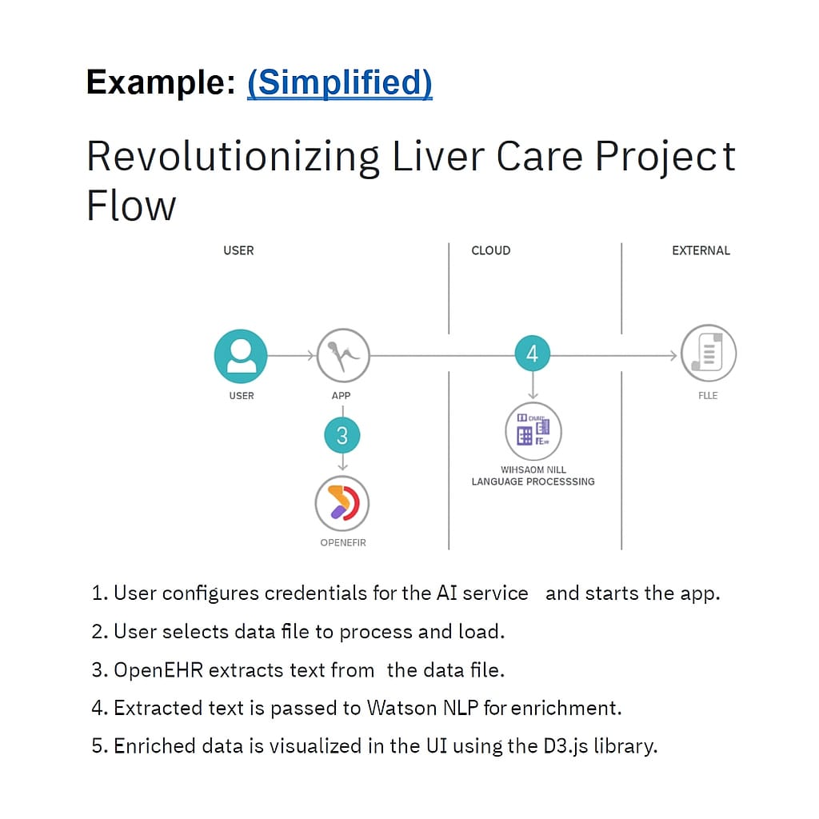

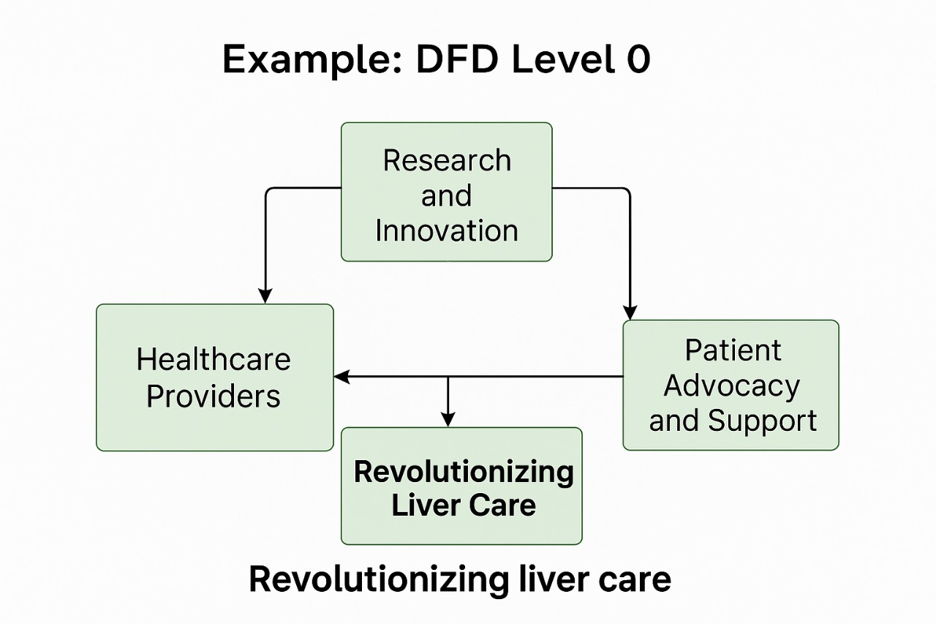

**User Stories**

Use the below template to list all the user stories for the product.

| **User Type** | **Functional Requirement (Epic)** | **User Story Number** | **User Story / Task** | **Acceptance criteria** | **Priority** | **Release** |
| --- | --- | --- | --- | --- | --- | --- |
| Data Engineer | Data Integration | USN-1 | As a developer, I want to collect and integrate liver test records and clinical data | Data sources integrated and stored in raw form | High | Sprint-1 |
| Data Engineer | Data Preprocessing | USN-2 | As a developer, I want to preprocess and clean the liver dataset | Dataset cleaned, transformed, and validated for modeling | High | Sprint-1 |
| ML Engineer | Model Building | USN-3 | As a developer, I want to build a model to predict the risk of liver cirrhosis | Model trained with ≥80% accuracy | High | Sprint-2 |
| ML Engineer | Model Evaluation | USN-4 | As a data scientist, I want to evaluate the model using precision, recall, and AUC | Metrics computed and performance validated | Medium | Sprint-2 |
| DevOps | Model Deployment | USN-5 | As a developer, I want to deploy the trained model for real-time liver risk prediction | Model hosted and accessible via REST API | High | Sprint-3 |
| Doctor (Admin) | Dashboard Access | USN-6 | As a doctor, I want to see cirrhosis predictions and patient status in a dashboard | Dashboard shows prediction scores and relevant clinical flags | High | Sprint-4 |
| Healthcare Provider | Clinical Insight Reports | USN-7 | As a clinician, I want to generate reports for at-risk patients | Reports exportable by patient ID/date and highlight risk levels | Medium | Sprint-3 |
| Patient | Health Monitoring | USN-8 | As a patient, I want to get notified if I'm at high risk based on recent test results | SMS/email alerts triggered for high-risk predictions | Low | Sprint-4 |
| Hospital IT Team | |  | | --- | | API Integration |  |  | | --- | |  | | USN-9 | As a developer, I want to integrate liver prediction API into hospital systems | API returns responses <2s and supports authentication | High | Sprint-2 |